Name: Hitendra Sisodia

Sap Id: 500091910

**Aim:**

Study of Network IP and Sub Netting & Super Netting.➢ Classification of IP address.

**Apparatus (Software):**

No Software or hardware needed.

**Theory:**

An Internet Protocol address (IP address) is a numerical label assigned to eachdevice (e.g., computer, printer) participating in a computer network that uses the InternetProtocol for communication. An IP address serves two principal functions: host or networkinterface identification and location addressing. Its role has been characterized as follows:"A name indicates what we seek. An address indicates where it is. A route indicates how toget there."

A sub network, or subnet, is a logically visible subdivision of an IP network. The practice ofdividing a network into two or more networks is called sub netting. A super network, or supernet, is an Internet Protocol (IP) network that is formed from the combination of two or morenetworks (or subnets) with a common Classless Inter-Domain Routing (CIDR) prefix. Thenew routing prefix for the combined network aggregates the prefixes of the constituentnetworks. It must not contain other prefixes of networks that do not lie in the same routingpath. The process of forming a super net is often called super netting, prefixaggregation, route aggregation, or route summarization.

**IP ADDRESS**

★ An IPv4 address is a 32-bit address that uniquely and universally defines the connection of a device (for example, a computer or a router) to the Internet.

★ An IPv4 address is 32 bits long.

★ Two devices on the Internet can never have the same address at the same time.

★ The address space of IPv4 is 4,294,967,296 (more than 4 billion).

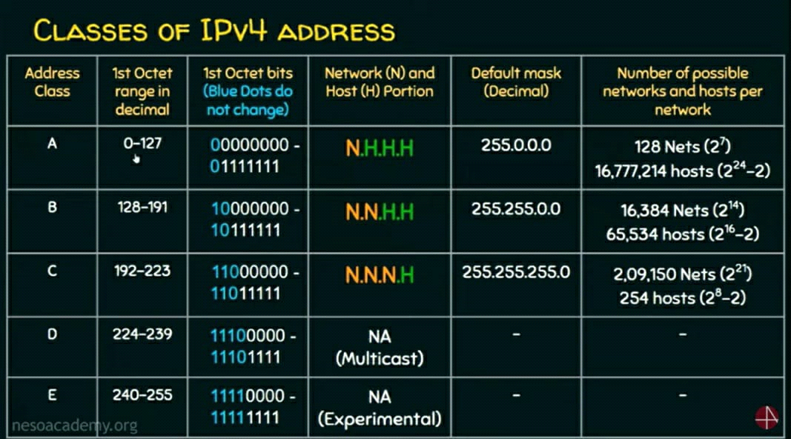

**Notations Of Ip Address**

★ There are two prevalent notations to show an IPv4 address: binary notation and dotted decimal notation.

★ Binary Notation: 01110101 10010101 00011101 00000010

★ Dotted-Decimal Notation: 117.149.29.2

★ Notation of IPv4 address: A.B.C.D (Only 4 octets)

★ O≤A, B, C, D≤ 255

★ 0.0.0.0 to 255.255.255.255

CLASSES OF IPV4 ADDRESSES AND ITS RANGE

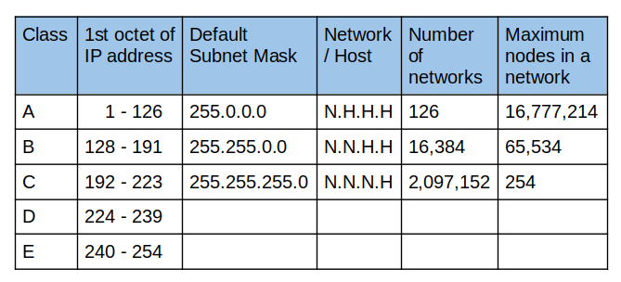

﻿

**1. Class A – (0-127)** addresses have a range of 1.0.0.0 to 126.0.0.0, with the first octet defining the network and the remaining three octets defining the host.

128 Nets (27)

16,77,214 hosts (224 -2)

**2. Class B – (128-191)** addresses have a range of 128.0.0.0 to 191.255.0.0, with the first two octets defining the network and the remaining two octets defining the host.

16,384 Nets (214)

65,534 hosts (216-2)

**3. Class C – (192-223)** addresses have a range of 192.0.0.0 to 223.255.255.0, with the first three octets defining the network and the remaining octet defining the host.

2,09,150 Nets (221)

254 hosts (218-2)

**4. Class D-(224-239)** addresses are reserved for multicast addressing.

**5. Class E-(240-255)** addresses are reserved for experimental use and are not to be used for public networks.

In conclusion, IP addresses are essential for communication on the Internet and the two main versions of IP addresses are IPv4 and IPv6. IP addresses are divided into five classes based on their values and these classes determine the size of the network and the number of hosts.

**Difference between IPv4 and IPv6.**

Address Space: IPv4 uses 32-bit addresses and can support up to 4.3 billion unique addresses, while IPv6 uses 128-bit addresses and can support up to 340 trillion, trillion, trillion addresses.

**Address Format:** IPv4 addresses are written as four decimal numbers separated by dots (e.g., 192.168.1.1), while IPv6 addresses are written as eight groups of hexadecimal numbers separated by colons (e.g., 2001:0db8:85a3:0000:0000:8a2e:0370:7334).

**Header Format:** IPv6 has a simpler header format compared to IPv4, which results in faster processing and improved efficiency.

**Security:** IPv6 has built-in security features, such as IPsec, which provide better protection against unauthorized access and hacking compared to IPv4.

**Mobility:** IPv6 provides better support for mobile devices, as it allows for easier renumbering and reconfiguration of networks, which is not possible with IPv4.

In summary, IPv6 is an upgrade to IPv4 and offers many advantages, such as a larger address space, simpler header format, improved security, and better

support for mobility. However, the transition from IPv4 to IPv6 is ongoing and many devices and networks still use IPv4.

**Subnet Mask**

★ To define the network and host portions of an address, devices use a separate 32-bit pattern called a subnet mask.

★ The subnet mask does not actually contain the network or host portion of an IPv4 address, it just says where to look for these portions in a given IPv4 address.

Let’s look at an example:

The IP address for a device may be:

192.168.123.132

11000000. 10101000. 01111011. 10000100

The subnet mask for the IP network above:

255.255.255.0

11111111. 11111111. 11111111. 00000000

**Subnetting**

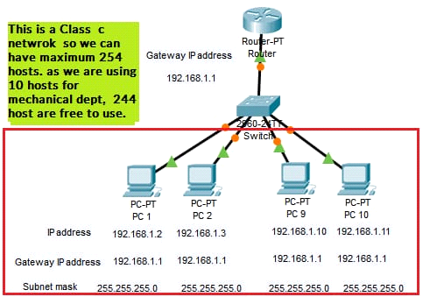

★Subnetting is a part of Network Layer. The duty of the network layer is to divide the received message into separate components and activities.

★Subnetting should be done in such a way that network does not gets affected. This means that we can divide the network into different parts but all when put together should perform the same task when done before splitting in to small parts.

★Subnetting is a technique for creating logical sub-networks from a single physical network (subnets).

## **Advantages of Subnetting**

* Subnetting is used to decrease the presence of Internet Protocol (IP) range.
* Subnets helps in stopping the devices or gadgets from occupying the whole network, only allowing the hosts to control which kind of user can have access to the important information. Simply, we can tell that network is safe just because of the subnetting concept.
* Subnetting concept increases the performance of the total network by deleting the repeated traffic causing errors.

## **Disadvantages of Subnetting**

* If the number of subnets increases, then the number of routers must also increase along with the subnet increase number. This happens because each subnet has its own subnet mask, broadcast address and network address.
* As told earlier, if we create many subnets many IP Addresses are wasted because of the wastage of Host ID Bits
* The cost of the entire network is increased by subnetting, which calls for the acquisition of pricey internal routers, switches, hubs, and bridges, among other things.

**Super Netting**

**Super netting** is the opposite of [Subnetting](https://www.geeksforgeeks.org/ip-addressing-classless-addressing/).  In Super netting, multiple networks are combined into a bigger network termed as a Super network or Super net. When multiple networks are combined to form a bigger network, it is termed super-netting. There are some points which should be kept in mind while super netting:

All the Networks should be contiguous.

The block size of every network should be equal and must be in form of 2n.

First Network id should be exactly divisible by whole size of super net.

**Example –** Suppose 4 small networks of class C: 

200.1.0.0,

200.1.1.0,

200.1.2.0,

200.1.3.0

Build a bigger network that has a single Network Id.

**Explanation –** Before Super netting routing table will look like as:

| **Network Id** | **Subnet Mask** | **Interface** |
| --- | --- | --- |
| 200.1.0.0 | 255.255.255.0 | A |
| 200.1.1.0 | 255.255.255.0 | B |
| 200.1.2.0 | 255.255.255.0 | C |
| 200.1.3.0 | 255.255.255.0 | D |

First, let’s check whether three conditions are satisfied or not:

* **Contiguous:** You can easily see that all networks are contiguous all having size 256 hosts.   
  Range of first Network from 200.1.0.0 to 200.1.0.255. If you add 1 in last IP address of first network that is 200.1.0.255 + 0.0.0.1, you will get the next network id which is 200.1.1.0. Similarly, check that all network is contiguous.
* **Equal size of all network:** As all networks are of class C, so all of them have a size of 256 which is in turn equal to 28.
* **First IP address exactly divisible by total size:** When a binary number is divided by 2n then last n bits are the remainder. Hence in order to prove that first IP address is exactly divisible by while size of Super net Network. You can check that if last n v=bits are 0 or not.

In the given example first IP is 200.1.0.0 and whole size of super net is 4*28 = 210. If last 10 bits of first IP address are zero then IP will be divisible.

**Differentiate Between Sub Netting And Super Netting**

Subnetting is the process of dividing a larger network into smaller, more manageable sub-networks. Each subnet is a separate network with its own unique IP address range and subnet mask. Subnetting helps to reduce network congestion, improve network security, and better allocate network resources.

Super netting, on the other hand, is the process of combining multiple smaller networks into a single, larger network. This is done by aggregating multiple IP address ranges and using a single, larger subnet mask. Super netting reduces the number of routes required in a network and conserves IP address space.

In summary, subnetting is used to divide a large network into smaller sub-networks, while super netting is used to combine multiple smaller networks into a single, larger network.